Case 17-Taino-Ancestor Figure-Stone Block-1400 CE

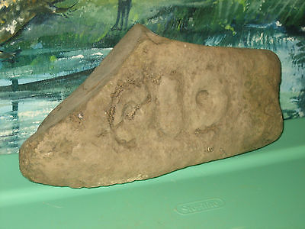

#### [TAINO - DOMINICAN REPUBLIC STONE CARVING ROCK SCULPTURE ARTIFACT FOSSIL # 19](http://www.ebay.com/itm/201491787395)

|  |  |
| --- | --- |
| Item price | $76.00 |
| Quantity | 1 |
| Item number | 201491787395 |
| Shipping service | Standard Shipping |